ENTREPRENEUR
An entrepreneur is a person who engages in an economic activity for profit, but does not perform that activity for the account of another.
The entrepreneur is responsible for all obligations related to the economic activity that he performs in his entire property.
If the entrepreneur does not carry on the activity under his own name but under another name, he is obliged to register that name or name in accordance with the provisions of this Law. In the event of a name change, the entrepreneur is required to report a change to the CRPS within 30 days of the change occurring.

How do I register?
In order to register an individual as an entrepreneur, the following must be submitted to CRPS:
- Fill out the entrepreneur registration form (the form can be downloaded from http://www.crps.me/)
- Pay tax administration 10.00€ to the account 832-3161-26
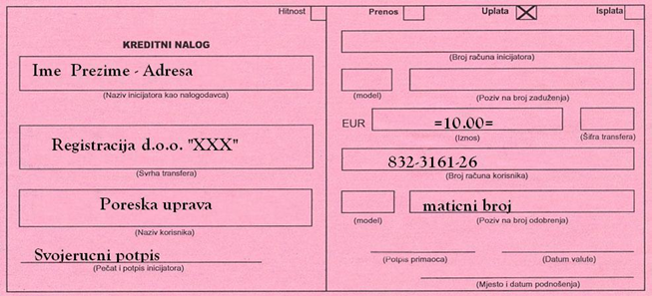
- Copy of the identity card of the entrepreneur or passport if the entrepreneur is not a citizen of Montenegro
- Submit the collected and certified documentation to CRPS at Vaka Djurovica 20, 81000 Podgorica (Tel: +382 (0) 20 230 858, e-mail: crps@tax.gov.me, working hours from 08:30 to 12:00)
When submitting documentation, you will receive a confirmation with your solution number, which you can check at http://www.crps.me/ for registration.
What to do next after registration?
After you have registered as an entrepreneur, you need to do the following:
- Make a stamp
- Report to the Tax Administration
- Open a bank account
To file in the Tax Administration, you need:
- Fill in the JPR form with Appendix B, you can download the form from http://www.poreskauprava.gov.me/management
- Decision on registration of entrepreneurs from the central register of tax administration
- Copy of the identity card of the entrepreneur or passport if the entrepreneur is not a citizen of Montenegro
- The seal of the entrepreneur
- Registration of activities (with the competent local authority)
- Documents and stamps must be attached to the local tax office.
How to open a bank account as an entrepreneur?
To open an account with a bank as an entrepreneur, you need to go to your chosen bank and submit the following:
- Completed and verified OP form (certified by the municipality, court or by a notary public) – the OP form can be downloaded from http://www.asistent.me/dw/obrasci/opobrazac.pdf
- Certificate of registration of entrepreneurs from the central register
- Identity card or passport of the authorized representative
- The seal of the entrepreneur
- Decision on filing with the Tax Administration

LIMITED LIABILITY COMPANY - LTD
Limited liability companies may be founded by natural or legal persons, up to 30 of them, who are responsible for the obligations of the company up to the level of their roles.
This type of registration is most common in our country and is very suitable for small businesses that can start one or more persons.
The amount of share capital must be a minimum of 1,00€.
In its name, the company must contain the name LLC.
By paying the initial stake, the persons acquire a share in the company in proportion to the size of their stake, and the acquisition of the shareholding become members of the company.
A member of the company owns only one share in the company which represents his percentage owned by the capital.
A shareholding in a company may entitle a member to have more than one vote.

How do I register?
In order to register following documents must be submitted to CRPS:
- The founding act (the decision or the founding contract) which is certified by the court in accordance with the law (forms for establishing a one-member LLC and a multi-member LLC can be downloaded from http://www.privrednakomora.me/how-to register-company)
- Confirm the contract / decision in the Court or with the Notary public, in 2 copies
- Company's Articles of Association (they can be downloaded from http://www.privnakomora.me/how to register- company)
- Excerpt from the Central Depository Agency. When raising a statement, a copy of your ID or passport must be enclosed if the founder is a foreigner and a payment slip of 5.00€ to one of the CDA accounts: 510-8092-14 or 550-3143-63 (below is an example how to fill out the payment slip)
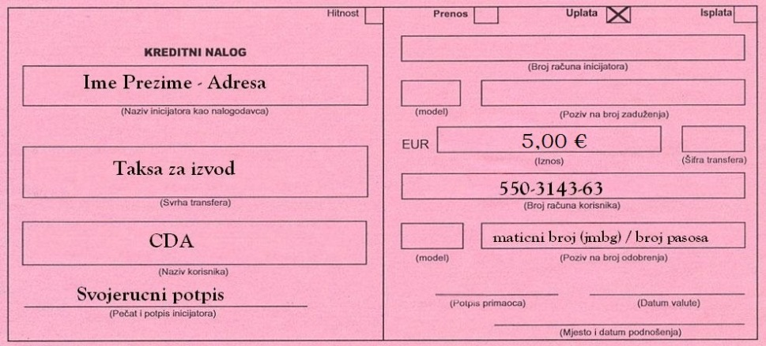
Written approval of the members of the board of directors which are choosen
Pay for the following administrative fees:
- 10,00 € (Tax Administration: 832-3161-26)
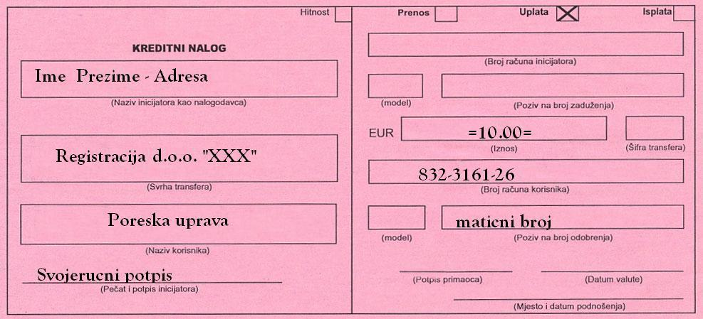
- 12,00€ (“Službeni list CG”: 520-941100-57)
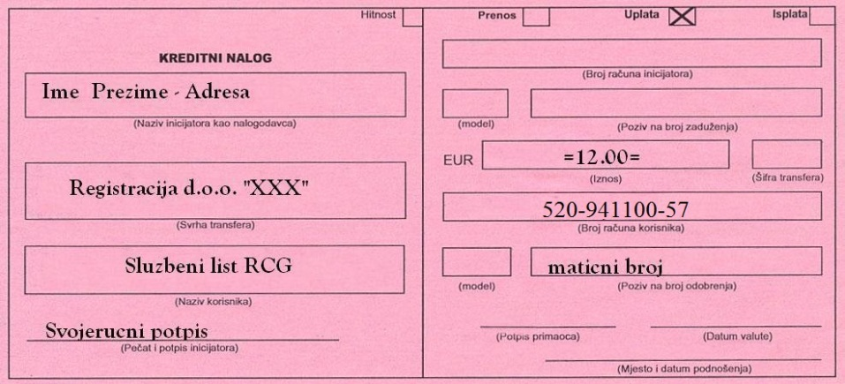
- PS01 registration form completed
- Certified (in the court or notary public) copy of ID card or passport if the founder is a foreigner.
- Submit the collected and certified documentation to the CRPS at Marka Miljanova 54, 81000 Podgorica (Tel: +382 (0) 20 230 858, e-mail: crps@t-com.me, working hours from 08:30 to 12 : 00)

If the company wants to apply for registration of value added tax payers, the PR PDV-1 form needs to be completed
If the company wishes to apply for entry in the register of excise taxpayers, the AKC-P form needs to be filled in
If a company wishes to import and export products, it is necessary to fill in the box under number 15.4 'Customs register' at the back of the PS01, in order to register the company under the customs administration and obtain the customs number.
When submitting documentation, you will receive a confirmation with the number of your solved case, with which you can check at http://www.crps.me/ if your registration is done.

What to do next after registration?

After you have registered the LLC you need to do the following:
- Make a seal (make sure that the appearance of the seal corresponds to the description in the Statute)
- Open a bank account
- Report the worker(s) to the tax office

How to open a bank account as a legal entity or company?
To open a bank account as a legal entity or company (LLC) you need to go to your chosen bank and submit the following:
- Completed and certified (municipality, court or notary public) OP form
- Company registration certificate
- Statute or decision to establish
- PIB (Tax Identification Number) - you get a PIB when you register in the tax office
- Confirmation of registration from VAT tax administration
- Excerpt from statistics
- Identity card or passport of the authorized representative(s)
- Company seal

How to report a worker to the tax administration?

When filing a worker, you are required to submit to the Tax Administration the following:
- Employment contract between employer and employee
- Copy of employee ID card
- Filled out JPR form with Appendix B
- Copy of employee's workbook (first page and the page with the written school degree)
* If the worker is a foreign citizen, the procedure is the same, only the copy of the passport and a copy of the residence and work permit are required.

JOINT STOCK COMPANY - AD
A joint stock company is a company with at least two founders, which is established for the purpose of conducting a business activity and whose capital is divided into shares.
The founders conclude a company foundation agreement.
Shareholders can be domestic and resident individuals and legal entities.
By concluding a contract on founding a joint stock company, the founders become shareholders.
A joint stock company is liable for all its liabilities to all assets.
The shareholders are responsible for the obligations of the company up to the amount of their capital in the company.
The minimum capital for establishing a joint stock company is € 25,000.00.
A joint-stock company must contain the AD code in its name.
As a joint stock company, a bank, a stock exchange, an investment fund management company and an insurance company are registered.
The founding stake for establishing a bank is at least €5,000,000.00, the stock exchange is at least € 100,000.00, the investment fund management companies at least €175,000.00, and the insurance companies are €2,000,000.00 or €3,000,000 respectively depending on what type of insurance the company registers for.

How do I register?
When registering a joint stock company, the following must be submitted to the Central Register of Business Entities (CRPS):
- Company Statute (you can download the form from http://www.privnakomora.me/how to register- company)
- Founding act of a joint-stock company certified by a notary public or in court (an example of the founding act can be downloaded from http://www.asistent.me/akcionarsko.html)
- Decision on the appointment of the Board of Directors, Auditors, Secretaries and CEO
- Decision of the Securities and Exchange Commission (minimum founding stake € 25,000)
- Pay into the tax administration account € 50.00 to the account: 832-3161-26 (see copy of the payment slip above)
- Pay into the Official Gazette of Montenegro 12,00 € to the account: 520-941100-57 (see copy of payment slip above)
- Completed PS01 registration form (you can download the form from http://www.privnacomora.me/how-to register-company)
- Submit the collected and certified documentation to the CRPS at Marka Miljanova 54, 81000 Podgorica (Tel: +382 (0) 20 230 858, e-mail: crps@t-com.me, working hours from 08:30 to 12 : 00)
If the company wishes to apply for registration of value added taxpayers, the PR PDV-1 form needs to be filled in (you can download the form from http://www.privrednakomora.me/how-to register-company)
If the company wants to apply for entry in the register of excise taxpayers, the AKC-P form needs to be filled in (you can download the form from http://www.privnakomora.me/how-to register-company)
What to do next after registration?
- Make a seal (make sure that the appearance of the seal corresponds to the description in the Statute)
- Open a bank account
- Report the worker(s) to the tax office

* The procedure for opening a bank account and reporting employees to the tax office is the same as for LLC.

PARTNERSHIP COMPANY – (ORTAČKO DRUŠTVO – OD)
A partnership company is a company established by the contract of at least two persons or legal persons, with the property of a partner that is mutually determined, with the aim of making a profit.
In its name, the company is obligatory to include the code OD.
The partnership company is responsible for its obligations with the entire property of the partners, unless otherwise is defined in the contract.
The partners of the partnership are jointly and severally liable for all the obligations of the company with their entire property, unless otherwise specified with the creditor.

How do I register?
A partnership is registered for statistics purposes in the CRPS by filing a registration application, but the existence of a partnership is not conditional of its registration.
For registration it is necessary to submit to the Central Register of Business Entities (CRPS) the following:
- Pay the registration fee of € 10.00 into the account of the Tax Administration, number: 832-3161-26 (see copy of the payment slip above)
- A registration application containing: the name of the partnership, the names of the partners, their addresses and registration numbers (JMBG).
- The contract of partnership, if made, the partners may submit to CRPS.

COMMUNITY SOCIETY - KD
A limited partnership is a company of one or more persons called complementaries and one or more persons called commanders and collectively referred to as: a firm.
Complementaries are jointly and severally liable for all obligations of the Company.
Commanders are responsible for the obligations of the company to the extent of their roles.
The roles of commander may be in money or in matters and rights that are assessed.
The complainant and the commander may be a person or legal person.
In its title, the company must contain the symbol KD.

How do I register?
A limited partnership is registered in the Central Register of Business Entities (CRPS) by submitting:
- Statement or contract signed by all members of the company and containing the following information:
- the name of the company and the indication that the company was founded as a limited partnership
- headquarters of the company
- the period for which the company is founded and the date of commencement of the activity
- name, surname and identification number, or name of each member of the company
- the name of each person who has the capacity of commander
- role of commander and in what form (monetary or non-monetary)

- Registration fee of € 10.00 needs to be paid into the account of the Tax Administration, number: 832-3161-26 (see copy of the payment slip above)

