# Tivat

Tivat is located in the central part of the Bay of Kotor, below the Lovcen branch of Vrmac (710 m), on the northeast side of the town. Opposite is the bay of Tivat, also the largest of the four bays in Boka Kotorska. Tivat is the smallest municipality on the Montenegrin coast, but with great tourist and economic importance for the whole country. The municipality possesses an airport, which is the only air connection of this region to other destinations.

 The sea on the Tivat Riviera is clear and the air is refreshingly gentle. Due to the unique natural climate, as well as its geographical location, the city area is full of vegetation. In addition to the variety of local Mediterranean plants, numerous exotic plants that have been brought here by sailors from all over the world thrive here.

The area of ​​Tivat belongs to the area of ​​the Mediterranean (Mediterranean) climate, mild, the so-called. true Mediterranean climate or EU Mediterranean. The position of the Lustica peninsula significantly mitigates the effects of the south wind from the high seas, and the Vrmac hinterland protects against the onset of cold air currents from the north and east, creating a specific climate characterized by mild, rainy winters and dry, warm summers with many hours of sunshine and clear skies. The contrast of serenity and sunshine on the one hand, and humidity on the other, reflects the specificity of the whole climate, with high average air temperature, which, based on years of observations in Tivat, is 15C.

Bura (northeast wind), is the most common wind in winter periods while maestral (west wind) occurs mainly during summer months. Jugo (South wind) is frequent in the autumn and winter, and bringing higher temperatures and lots of rain.

Tivat is the sunniest town of Boka Kotorska with 2446.2 hours of sunshine during the year.

# History of Tivat

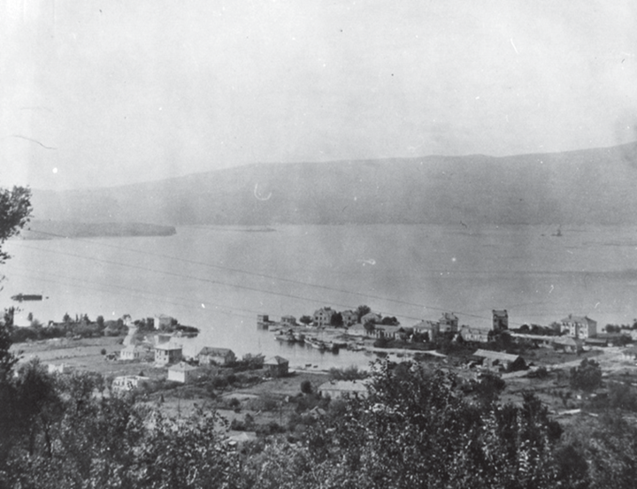According to historians, Tivat is the youngest town in Boka Kotorska, and even on the Montenegrin coast. There are three different opinions about the name of the city. One claims that the name Tivat derives from the name of the Illyrian Queen Teuta, who, in addition to her capital being Risan, also had several summer residences in the immediate vicinity of present-day Tivat. Another explanation refers to the names of Christian saints that resemble the name Tivat, for example: sanctus Theudorus, Theodosius, Theodotus, Theodulus, or medieval names dating from the 12th c. - Theudo, Teodo.

The third opinion, states that the name Tivat comes from the Celtic word "teuto",meaning the city.

Tivat began to develop as a city only at the end of the 19th century, when the naval port "Arsenal" was established. Until the construction of the Arsenal, the landholdings in Tivat were mostly in the hands of the feudal lords of Prcanja, Perast, Dobrota and Kotor.

Today, Tivat is a modern city oriented to the development of tourism. Small attractive ports, bays and numerous beaches with an area of ​​about 30,000 m2 are situated all along the coast.

With its location in the Bay of Kotor, the Prevlaka Peninsula and Sveti Marko Island, the luxury marina for mega yachts "Porto Montenegro", with its famous Przno beach, and other investment projects, Tivat is listed in tourist maps as an attractive tourist and nautical destination

